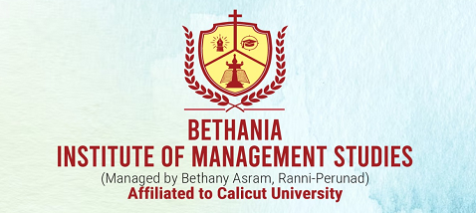

**Report on International Women's Day Program at Bethania Institute of Management Studies**

Event: International Women’s Day Celebration  
Date: March 7, 2025  
Time: 09:30 AM  
Venue: Bethania Institute of Management Studies (BIMS), Kunnamkulam  
Affiliation: University of Calicut, Approved by AICTE  
In Association With: IQAC

**Program Overview**

1. **Prayer:**
   * Led by the **College Prayer Team**, marking the spiritual beginning of the event.
2. **Welcome Speech:**
   * Delivered by **Ms. Asha P**, Assistant Professor, who extended a warm welcome to the guests, faculty, and students.
3. **Presidential Address:**
   * Given by **Dr. C L Joshy**, Principal of BIMS College, Kunnamkulam.
   * The address highlighted the importance of women’s empowerment, gender equality, and their contribution to society.
4. **Felicitation Address:**
   * Presented by **Fr. Benjamin OIC**, Manager of the Bethany Group of Institutions.
   * He acknowledged the achievements of women and emphasized the need for continued support for their progress.
5. **Keynote Address:**
   * Delivered by **Ms. Rema Raghunandan**, an advocate, counselor, and psychotherapist.
   * She is actively involved in women empowerment and child development as a South Indian Council member.
   * She also holds the roles of General Secretary at Kannan Memorial Charitable Trust and the Hemophilia Society in Kunnamkulam.
   * Her speech focused on women’s rights, mental health, and the importance of collective support in driving social change.
6. **Felicitation:**
   * **Ms. Aleena K G**, BIMS College Union Student Representative, addressed the audience, commending the institution’s efforts in promoting gender equality and women’s rights.
7. **Vote of Thanks:**
   * Delivered by **Ms. Sayana Santhosh**, BIMS College Union Joint Secretary.
   * She expressed gratitude to the guests, faculty, and organizing committee for their support and participation.

**MAIN EVENTS**

**✅ NOON SHOW: Film Screening**

As part of the celebration, the event featured a special **Noon Show** screening of the critically acclaimed and award-winning film:  
🎥 **Nomadland** (Oscar Winner, BAFTA Winner)

* Directed by **Chloé Zhao**
* Starring **Frances McDormand**
* Time: **01:00 PM**
* Venue: BIMS Seminar Hall

The film explores themes of resilience, freedom, and survival, reflecting the struggles and strengths of women living on the fringes of society. It provided a powerful narrative that resonated with the day’s theme of women’s empowerment.

**Conclusion**

The International Women’s Day celebration at BIMS College was a significant event promoting women’s empowerment and social awareness. The insightful speeches and addresses emphasized the need for continued advocacy and support for gender equality. The program successfully brought together students, faculty, and notable speakers to celebrate and honor the contributions of women in various fields.

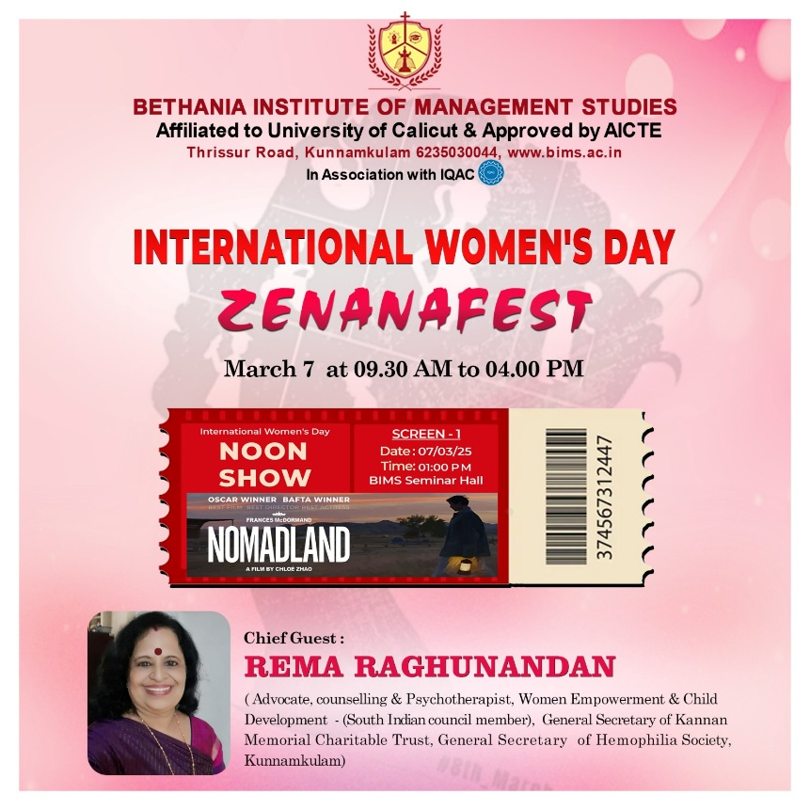

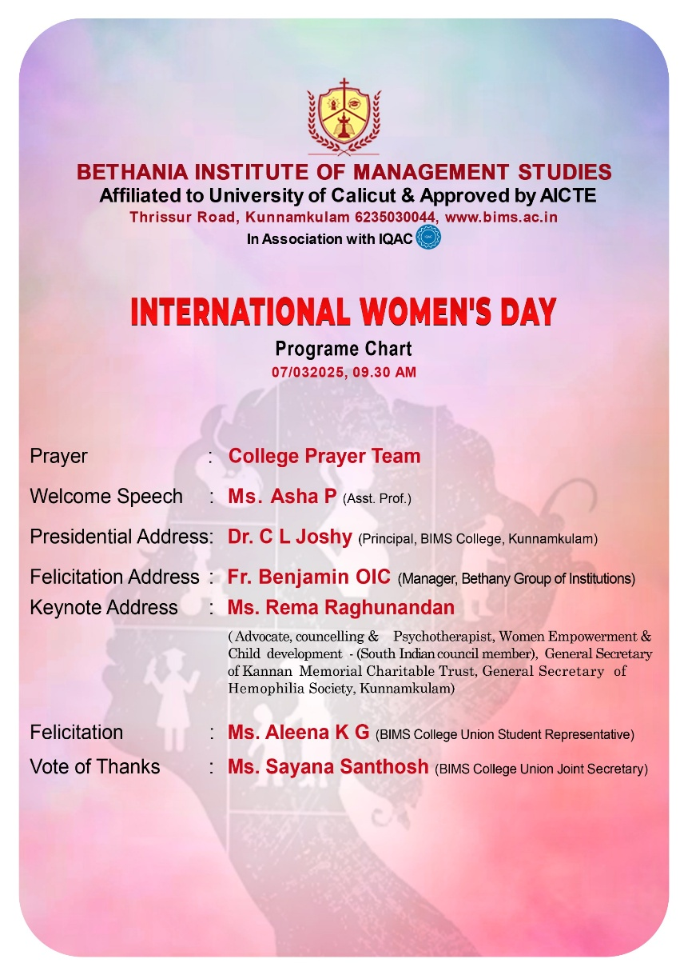

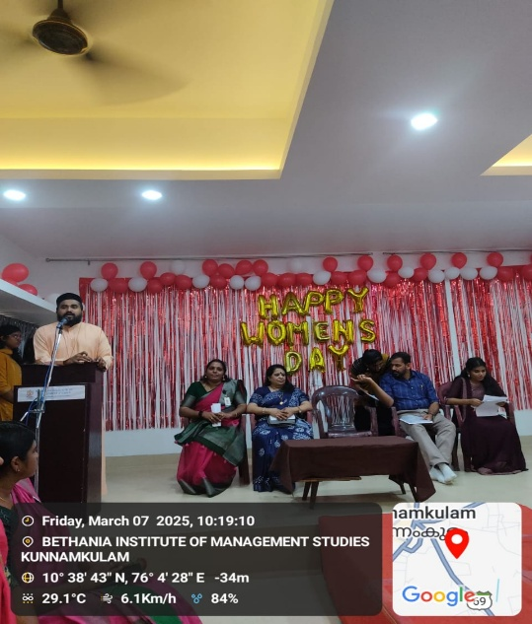 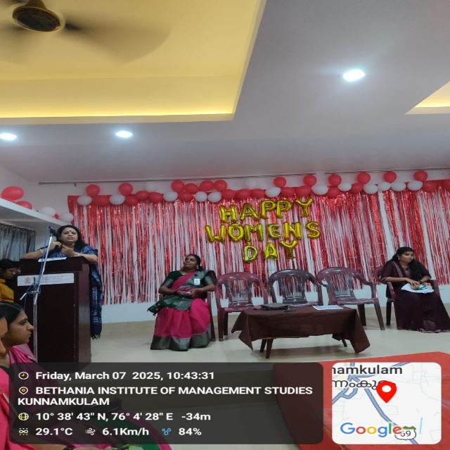

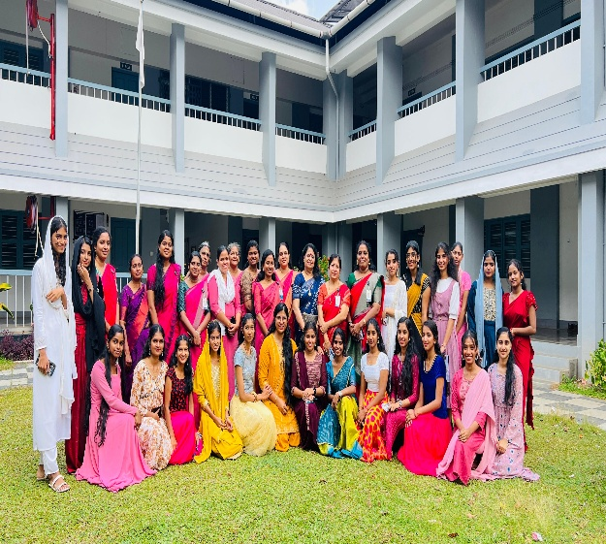 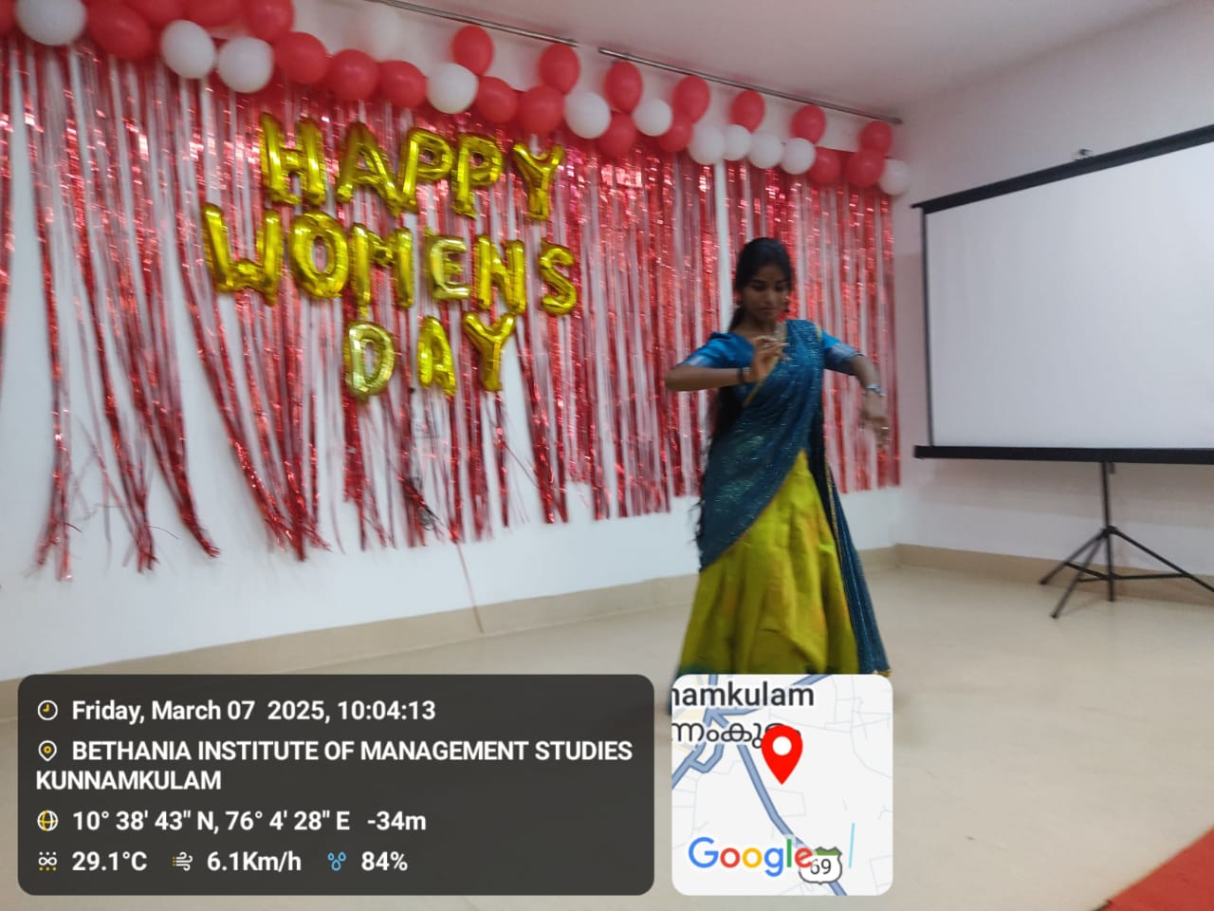

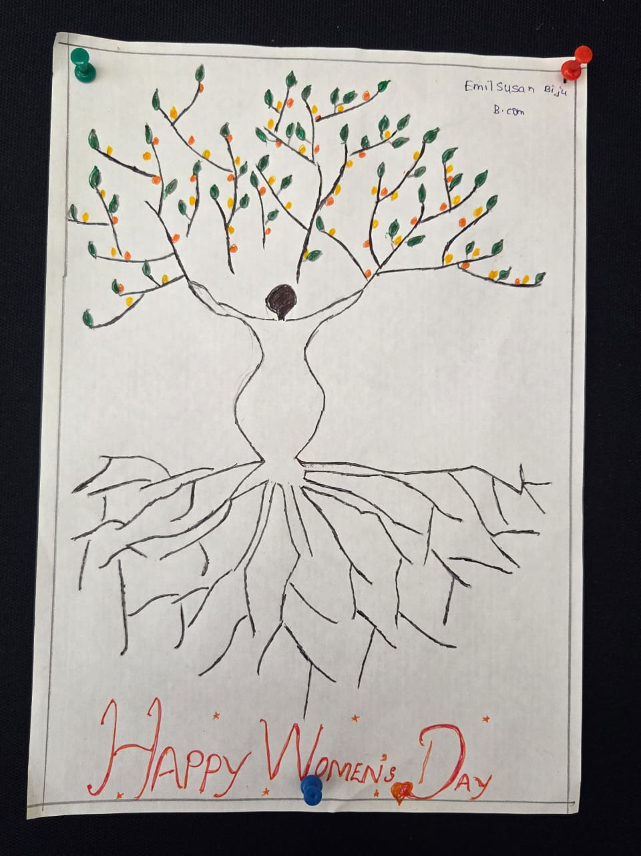

The programme was attended by about 92 students and 15 faculty members of Bethania Institute of Management Studies,Kunnamkulam